**PROJECT 3 - GROUP 1 PROPOSAL FEBRUARY 15, 2022**

* Colin Campbell
* Jorge Hernandez
* Jason Lister
* Prina Thaker
* Etienne Dembele
* Hamilton Cha

**OBJECTIVE/SUMMARY**

* Using state monthly average temperatures to create SQLite database for FLASK dashboard
* Data visualization to interactive plots and charts using HTML and Javascript that show trends in average temperature by state for month/year.

**DATA**

**Temperature by state by month SOURCE:** <https://www.ncei.noaa.gov/pub/data/cirs/climdiv/climdiv-tmpccy-v1.0.0-20220204>

* Data is monthly average temperature by state
* 1895-2021
* Select 10 states from across the USA across a variety of climates. States TBD.
  + WA, TX, FL, CA, MA, AK, HI, IL, AZ, NY
* Create a static table for states which will map 2 digit numeric code to state code
* Link the state table with text file
* Create final data set and load in SQLite DB

**DASHBOARD OF MULTIPLE CHARTS - VISUALIZATIONS:**

AVERAGE FOR ALL STATES

* “From date” and a “To date” display line graph of state average temperature between selected dates.

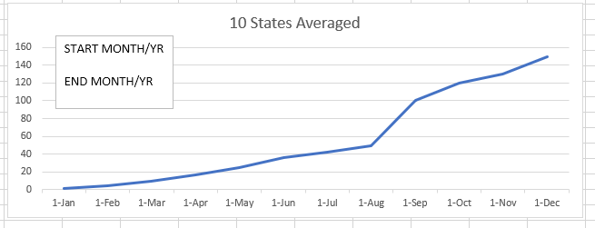

INTERACTIVE For Two STATES GRAPHS TO COMPARE STATES

* Side by Side Vertical Bar Chart
* Input Date and State and display specific weather for those values
  + Drop Down of States
  + Drop Down of Month/Year

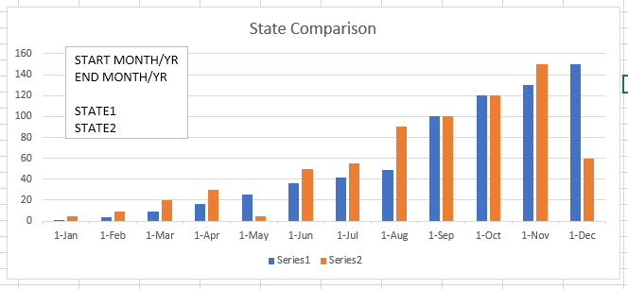

INTERACTIVE DATA TABLE WITH SORTING BY COLUMN



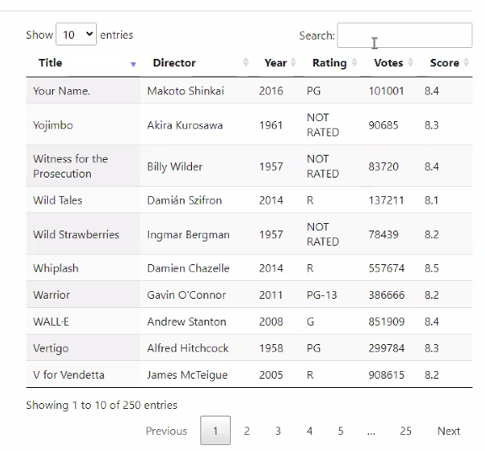

GeoSON MAP (if we have time)

* Marker display Date and average temperature MAX and MIN and MEAN